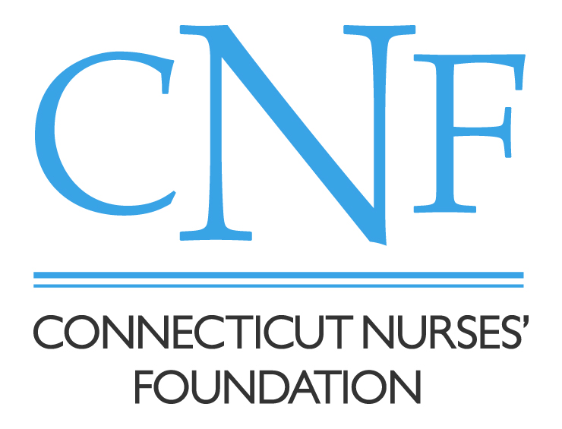

1224 Mill St, Bldg B, Suite 223, East Berlin, CT 06023
Office (203) 238-1207 | Fax (203) 238-3437
www.ctnursesfoundation.org

Linda Angotto Memorial Award
Nomination Form

All parts of the nomination form are to be completed electronically and submitted to the Scholarship Committee: CNFPresident@ctnurses.org by June 15th.

Nominee Information
Name and credentials: Click here to enter text.

Current Employment and Position employment: Click here to enter text.

Email Address: Click here to enter text.

Full Permanent address: Click here to enter text.
*Mailing address (if different from above): Click here to enter text.
Telephone: Click here to enter text.

Nominator Information
Name: Click here to enter text.
Email Address: Click here to enter text.

Full Permanent address: Click here to enter text.
*Mailing address (if different from above): Click here to enter text.
Telephone: Click here to enter text.

Relation to nominee: Click here to enter text.

Reason for Nomination
- How do you feel the nominee exemplifies the qualities of the Linda Angotto Memorial Award and the mission and vision of the Connecticut Nurses’ Foundation?

- How has this nominee contributed to the profession of nursing? Select and describe an example of the nominee’s merit and dedication to professional excellence.

- How has the nominee demonstrated a commitment to quality, patient-centered care?

- Please provide any further information you feel necessary for consideration of this nominee.

The Connecticut Nurses’ Foundation appreciates your submission of a nomination for the Linda Angotto Memorial Award. If there are any clarifying questions the Scholarship Committee reserves the right to contact you at the phone number or email address provided above.

Nominator’s Electronic Signature Click here to enter text. Date Click here to enter a date.

